**MODULE 2 STOCKS VBA CHALLENGE**

1. Create a script that loops through all the stocks for one year and outputs the following information:

* The ticker symbol
* Yearly change from the opening price at the beginning of a given year to the closing price at the end of that year.
* The percentage change from the opening price at the beginning of a given year to the closing price at the end of that year.

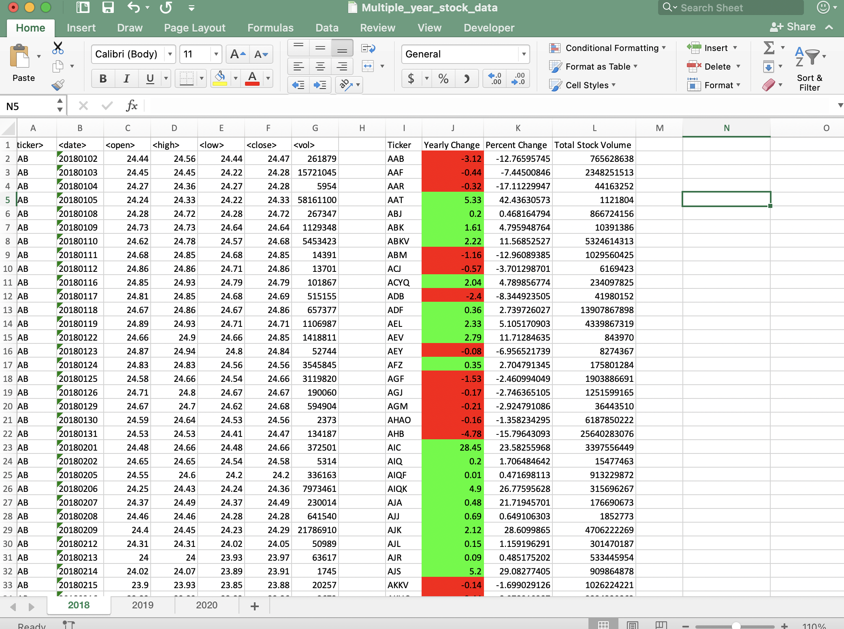

**Script 1st part**

**Sub StockAnalysis()**

**Dim ws As Worksheet**

**Dim lastRow As Long**

**Dim ticker As String**

**Dim openingPrice As Double**

**Dim closingPrice As Double**

**Dim yearlyChange As Double**

**Dim percentChange As Double**

**Dim totalVolume As Double**

**Dim summaryTableRow As Integer**

**Set ws = ThisWorkbook.Worksheets("2018")**

**lastRow = ws.Cells(ws.Rows.Count, 1).End(xlUp).Row**

**ws.Cells(1, 9).Value = "Ticker"**

**ws.Cells(1, 10).Value = "Yearly Change"**

**ws.Cells(1, 11).Value = "Percent Change"**

**ws.Cells(1, 12).Value = "Total Stock Volume"**

**summaryTableRow = 2**

**For i = 2 To lastRow**

**If ws.Cells(i, 1).Value <> ws.Cells(i - 1, 1).Value Then**

**ticker = ws.Cells(i, 1).Value**

**openingPrice = ws.Cells(i, 3).Value**

**End If**

**totalVolume = totalVolume + ws.Cells(i, 7).Value**

**If ws.Cells(i, 1).Value <> ws.Cells(i + 1, 1).Value Then**

**closingPrice = ws.Cells(i, 6).Value**

**yearlyChange = closingPrice - openingPrice**

**percentChange = (yearlyChange / openingPrice) * 100**

**ws.Cells(summaryTableRow, 9).Value = ticker**

**ws.Cells(summaryTableRow, 10).Value = yearlyChange**

**ws.Cells(summaryTableRow, 11).Value = percentChange**

**ws.Cells(summaryTableRow, 12).Value = totalVolume**

**If yearlyChange >= 0 Then**

**ws.Cells(summaryTableRow, 10).Interior.Color = RGB(0, 255, 0)**

**Else**

**ws.Cells(summaryTableRow, 10).Interior.Color = RGB(255, 0, 0)**

**End If**

**If percentChange > greatestIncrease Then**

**greatestIncrease = percentChange**

**greatestIncreaseTicker = ticker**

**End If**

**If percentChange < greatestDecrease Then**

**greatestDecrease = percentChange**

**greatestDecreaseTicker = ticker**

**End If**

**If totalVolume > greatestVolume Then**

**greatestVolume = totalVolume**

**greatestVolumeTicker = ticker**

**End If**

**summaryTableRow = summaryTableRow + 1**

**ticker = ""**

**openingPrice = 0**

**closingPrice = 0**

**yearlyChange = 0**

**percentChange = 0**

**totalVolume = 0**

**End If**

**Next i**

**End Sub**

2) Add functionality to your script to return the stock with the "Greatest % increase", "Greatest % decrease", and "Greatest total volume"

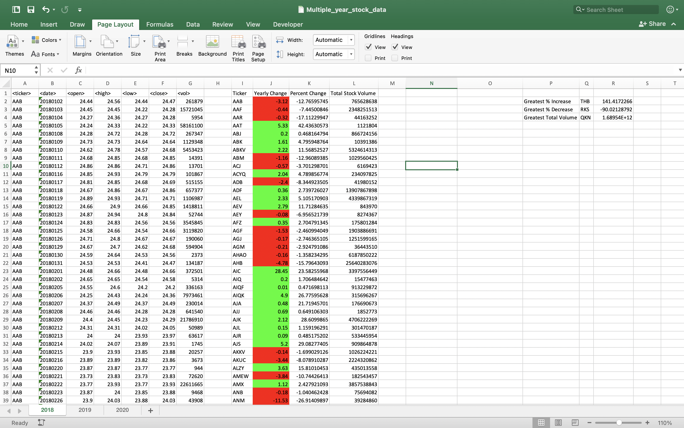

**Script 2**

**Sub StockAnalysis()**

**Dim ws As Worksheet**

**Dim lastRow As Long**

**Dim ticker As String**

**Dim openingPrice As Double**

**Dim closingPrice As Double**

**Dim yearlyChange As Double**

**Dim percentChange As Double**

**Dim totalVolume As Double**

**Dim summaryTableRow As Integer**

**Dim greatestIncrease As Double**

**Dim greatestDecrease As Double**

**Dim greatestVolume As Double**

**Dim greatestIncreaseTicker As String**

**Dim greatestDecreaseTicker As String**

**Dim greatestVolumeTicker As String**

**Set ws = ThisWorkbook.Worksheets("2018")**

**lastRow = ws.Cells(ws.Rows.Count, 1).End(xlUp).Row**

**ws.Cells(1, 9).Value = "Ticker"**

**ws.Cells(1, 10).Value = "Yearly Change"**

**ws.Cells(1, 11).Value = "Percent Change"**

**ws.Cells(1, 12).Value = "Total Stock Volume"**

**summaryTableRow = 2**

**greatestIncrease = 0**

**greatestDecrease = 0**

**greatestVolume = 0**

**For i = 2 To lastRow**

**If ws.Cells(i, 1).Value <> ws.Cells(i - 1, 1).Value Then**

**ticker = ws.Cells(i, 1).Value**

**openingPrice = ws.Cells(i, 3).Value**

**End If**

**totalVolume = totalVolume + ws.Cells(i, 7).Value**

**If ws.Cells(i, 1).Value <> ws.Cells(i + 1, 1).Value Then**

**closingPrice = ws.Cells(i, 6).Value**

**yearlyChange = closingPrice - openingPrice**

**percentChange = (yearlyChange / openingPrice) * 100**

**ws.Cells(summaryTableRow, 9).Value = ticker**

**ws.Cells(summaryTableRow, 10).Value = yearlyChange**

**ws.Cells(summaryTableRow, 11).Value = percentChange**

**ws.Cells(summaryTableRow, 12).Value = totalVolume**

**If yearlyChange >= 0 Then**

**ws.Cells(summaryTableRow, 10).Interior.Color = RGB(0, 255, 0)**

**Else**

**ws.Cells(summaryTableRow, 10).Interior.Color = RGB(255, 0, 0)**

**End If**

**If percentChange > greatestIncrease Then**

**greatestIncrease = percentChange**

**greatestIncreaseTicker = ticker**

**End If**

**If percentChange < greatestDecrease Then**

**greatestDecrease = percentChange**

**greatestDecreaseTicker = ticker**

**End If**

**If totalVolume > greatestVolume Then**

**greatestVolume = totalVolume**

**greatestVolumeTicker = ticker**

**End If**

**summaryTableRow = summaryTableRow + 1**

**ticker = ""**

**openingPrice = 0**

**closingPrice = 0**

**yearlyChange = 0**

**percentChange = 0**

**totalVolume = 0**

**End If**

**Next i**

**ws.Cells(2, 16).Value = "Greatest % Increase"**

**ws.Cells(2, 17).Value = greatestIncreaseTicker**

**ws.Cells(2, 18).Value = greatestIncrease**

**ws.Cells(3, 16).Value = "Greatest % Decrease"**

**ws.Cells(3, 17).Value = greatestDecreaseTicker**

**ws.Cells(3, 18).Value = greatestDecrease**

**ws.Cells(4, 16).Value = "Greatest Total Volume"**

**ws.Cells(4, 17).Value = greatestVolumeTicker**

**ws.Cells(4, 18).Value = greatestVolume**

**End Sub**

**3)** Make the appropriate adjustments to your VBA script to enable it to run on every worksheet (that is, every year) at once.

**2018**

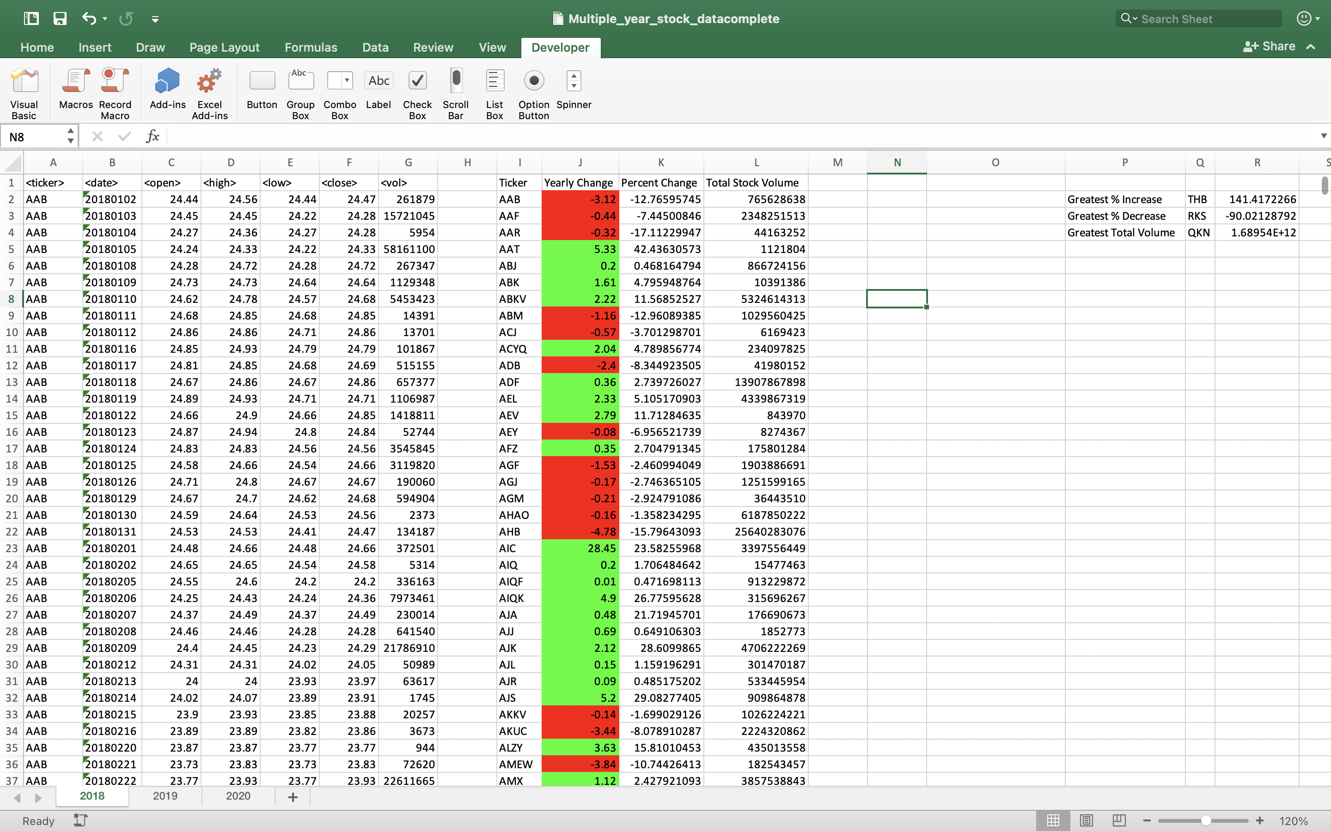

**2019**

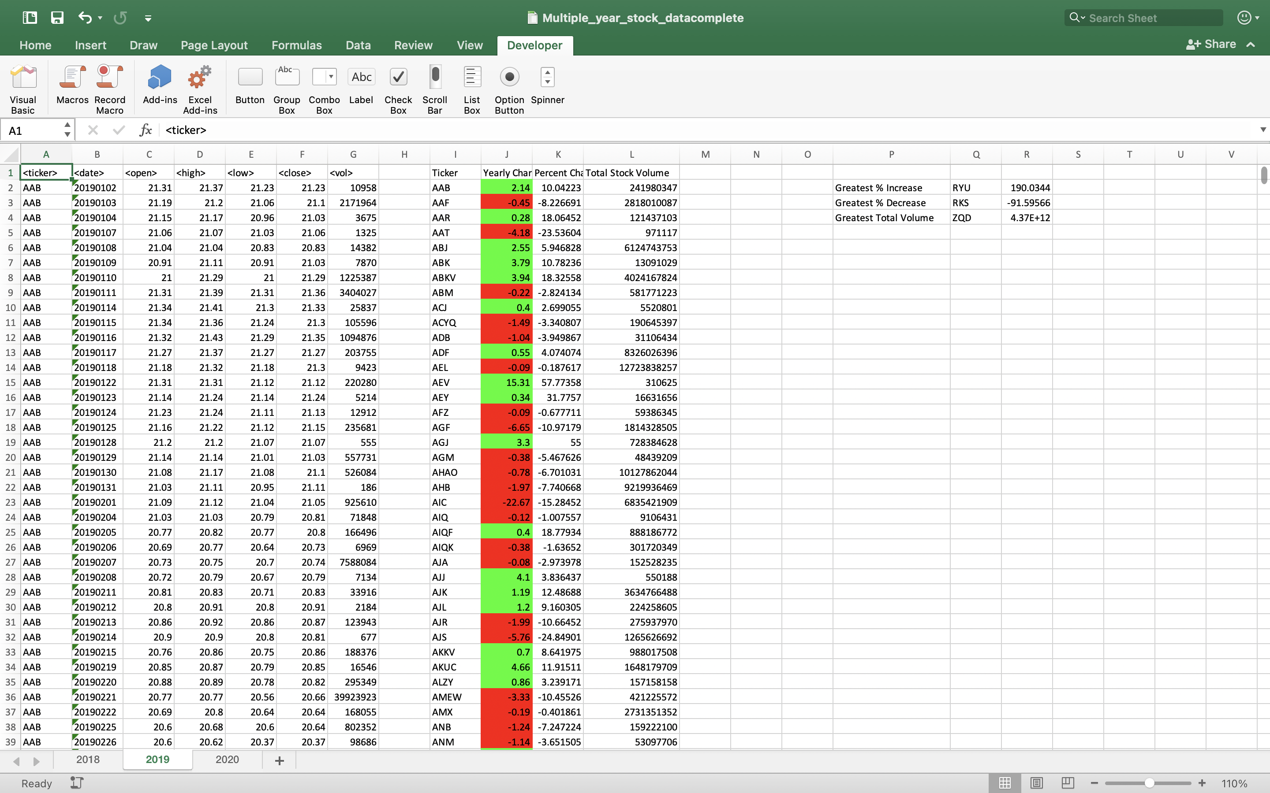

**2020**

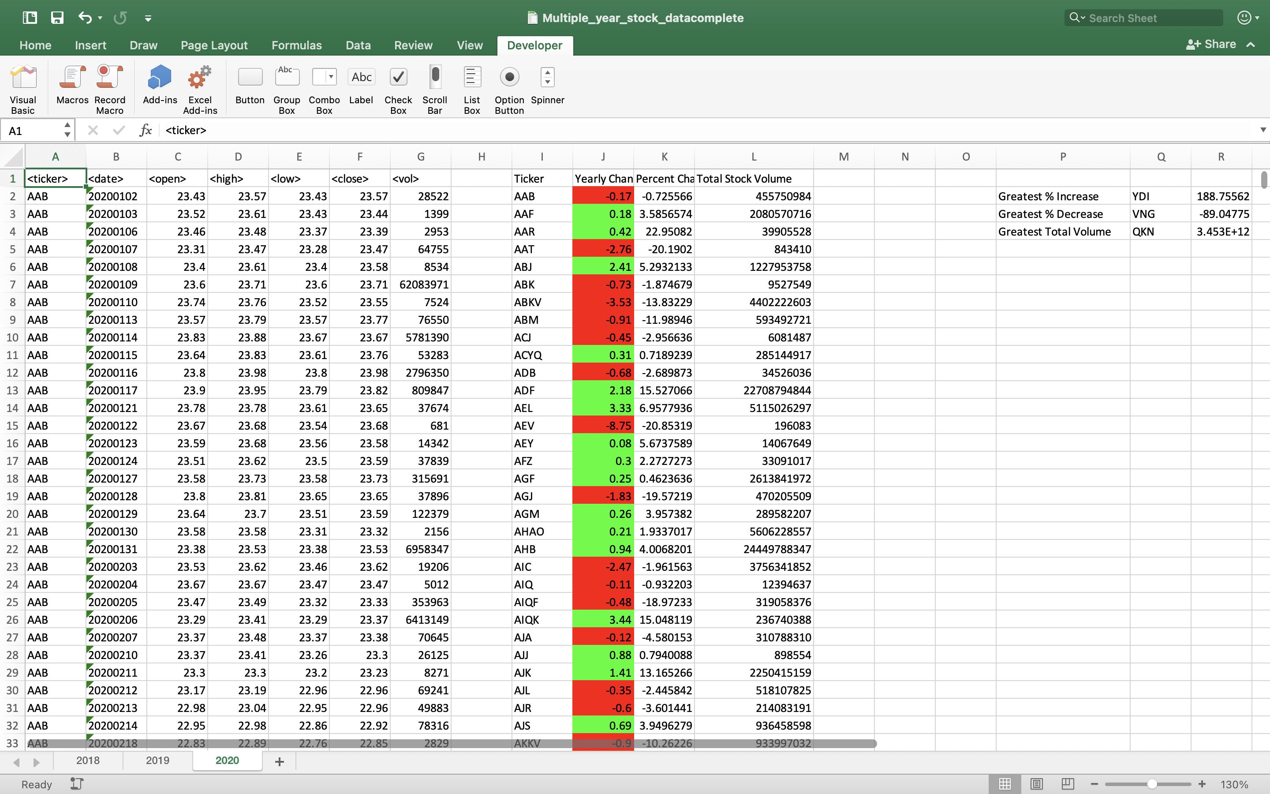

**Scrip 3**

**Sub StockAnalysis()**

**Dim ws As Worksheet**

**Dim lastRow As Long**

**Dim ticker As String**

**Dim openingPrice As Double**

**Dim closingPrice As Double**

**Dim yearlyChange As Double**

**Dim percentChange As Double**

**Dim totalVolume As Double**

**Dim summaryTableRow As Integer**

**Dim greatestIncrease As Double**

**Dim greatestDecrease As Double**

**Dim greatestVolume As Double**

**Dim greatestIncreaseTicker As String**

**Dim greatestDecreaseTicker As String**

**Dim greatestVolumeTicker As String**

**For Each ws In ThisWorkbook.Worksheets**

**If IsNumeric(Left(ws.Name, 1)) Then**

**lastRow = ws.Cells(ws.Rows.Count, 1).End(xlUp).Row**

**ws.Cells(1, 9).Value = "Ticker"**

**ws.Cells(1, 10).Value = "Yearly Change"**

**ws.Cells(1, 11).Value = "Percent Change"**

**ws.Cells(1, 12).Value = "Total Stock Volume"**

**summaryTableRow = 2**

**greatestIncrease = 0**

**greatestDecrease = 0**

**greatestVolume = 0**

**For i = 2 To lastRow**

**If ws.Cells(i, 1).Value <> ws.Cells(i - 1, 1).Value Then**

**ticker = ws.Cells(i, 1).Value**

**openingPrice = ws.Cells(i, 3).Value**

**End If**

**totalVolume = totalVolume + ws.Cells(i, 7).Value**

**If ws.Cells(i, 1).Value <> ws.Cells(i + 1, 1).Value Then**

**closingPrice = ws.Cells(i, 6).Value**

**yearlyChange = closingPrice - openingPrice**

**percentChange = (yearlyChange / openingPrice) * 100**

**ws.Cells(summaryTableRow, 9).Value = ticker**

**ws.Cells(summaryTableRow, 10).Value = yearlyChange**

**ws.Cells(summaryTableRow, 11).Value = percentChange**

**ws.Cells(summaryTableRow, 12).Value = totalVolume**

**If yearlyChange >= 0 Then**

**ws.Cells(summaryTableRow, 10).Interior.Color = RGB(0, 255, 0)**

**Else**

**ws.Cells(summaryTableRow, 10).Interior.Color = RGB(255, 0, 0)**

**End If**

**If percentChange > greatestIncrease Then**

**greatestIncrease = percentChange**

**greatestIncreaseTicker = ticker**

**End If**

**If percentChange < greatestDecrease Then**

**greatestDecrease = percentChange**

**greatestDecreaseTicker = ticker**

**End If**

**If totalVolume > greatestVolume Then**

**greatestVolume = totalVolume**

**greatestVolumeTicker = ticker**

**End If**

**summaryTableRow = summaryTableRow + 1**

**ticker = ""**

**openingPrice = 0**

**closingPrice = 0**

**yearlyChange = 0**

**percentChange = 0**

**totalVolume = 0**

**End If**

**Next i**

**ws.Cells(2, 16).Value = "Greatest % Increase"**

**ws.Cells(2, 17).Value = greatestIncreaseTicker**

**ws.Cells(2, 18).Value = greatestIncrease**

**ws.Cells(3, 16).Value = "Greatest % Decrease"**

**ws.Cells(3, 17).Value = greatestDecreaseTicker**

**ws.Cells(3, 18).Value = greatestDecrease**

**ws.Cells(4, 16).Value = "Greatest Total Volume"**

**ws.Cells(4, 17).Value = greatestVolumeTicker**

**ws.Cells(4, 18).Value = greatestVolume**

**End If**

**Next ws**

**End Sub**